- Select ‘1. Parcel Maint’ on the ‘Main Menu’ once on that screen enter a new parcel id in the parcel id field. A window will appear asking if you want to create a new parcel with this parcel id. Click ‘Yes’ to continue creating the parcel or click ‘No’ to cancel this process.

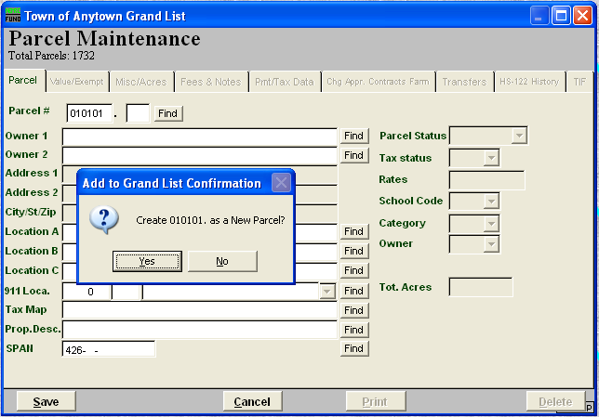

2. Next you must choose whether this parcel is Real estate or Personal property. Certain fields will become inactive depending on your selection. For example: If you select ‘Real’ then the Personal Property value fields will not show on the ‘Value Exempt’ screen. And if you select ‘Personal’ then the Category, Owner code, Real value, Homestead, and Housesite fields will not be shown.

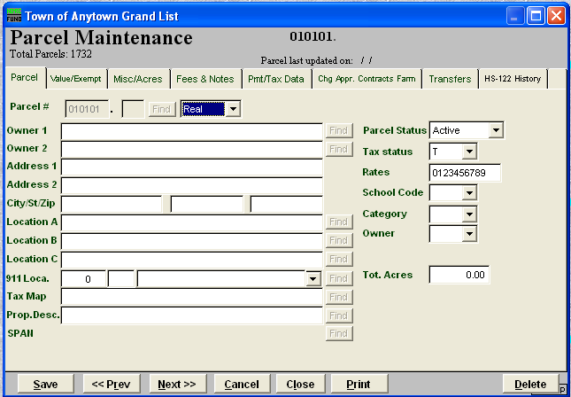

3. Enter all of your parcel information Name Address etc. Navigate through each of the tabs on this screen filling in the appropriate fields. Click the ‘Save’ button when you are finished.
If you are linked to the NEMRC/MSOL Cama program then you will enter the base information such as Name and Address. Then you will open the MSOL Cama program and begin entering your appraisal information for this new parcel. Once you finish entering the appraisal data and you have a new value for this parcel the new value will be transferred to the NEMRC Grand List.

